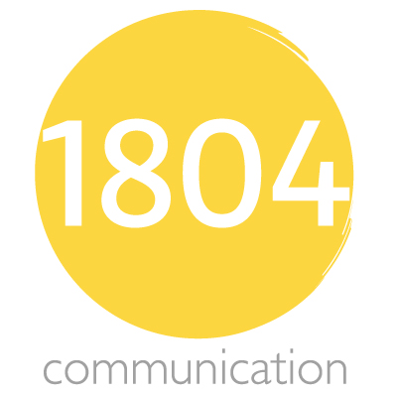

1804 Communications Associate Application
We’re so glad you’re here. Please fill out this form so we can learn a little bit more about you!

Name: ______________________________________
Email: ______________________________________
Major: ______________________________________

Year (Please circle one): Freshman Sophomore Junior Senior

Department Overview
1. Client Services: As an associate in this department, you will serve as a liaison between the client and the rest of the firm. You'll also gain valuable experience in client relations, and you will likely have the opportunity to work with various clients.

2. Creative Department: Associates in the creative department will have the opportunity to create marketing materials for clients, campaigns, and the firm as a whole. In this department, you will also have the opportunity to participate in event planning and campaign strategy.

3. Business Development: Associates in business development will be responsible for the implementation of successful business proposals. As an associate in this department, your goal will be to make campaign ideas a reality, which will be a valuable asset to the success of our clients.

4. Strategy & Media: In this department, associates will have the ability to exercise valuable social media skills including media campaigns and account management. This will boost the public's knowledge of our clients, as well as their respective platforms.

5. Internal Operations: As an associate in internal operations, you will serve as an asset to company culture and communications. Associates in this department will act as a link between internal operations and the other departments of the firm.
Do you have any experience with 1804 Communication? If so, what position did you hold, and what were your responsibilities?

Please list your preferred departments from 1 (most desirable) to 5 (least desirable)

What experience do you have that you feel would be beneficial to this department? Why do you think you would be a good fit for your top department choice?

What skill(s) are you hoping to gain/improve upon from this department?

What skill(s) are you hoping to gain/improve upon from being a team member in 1804 Communication as a whole?

Additional comments:

Thank you so much for filling out this form! We are excited to work with you this year!

